Envirothon Soils Station

Importance of Soils
Food – directly or indirectly
Fiber (trees, cotton, etc.)
Fuel (wood, ethanol, corn & pellets)
Buildings - foundations
Recyles and detoxifies waste

Soil Definition
- A living, naturally occurring dynamic system at the interface of air and rock. Soil forms in response to forces of climate and organisms that act on parent material in a specific landscape (topography) over a period of time.

What is soil composed of?
Mineral material
organic matter (dead plants, animals, microorganisms)
soil teaspoon -100million bacteria – 50,000 species (kinds)
living organisms
air
water
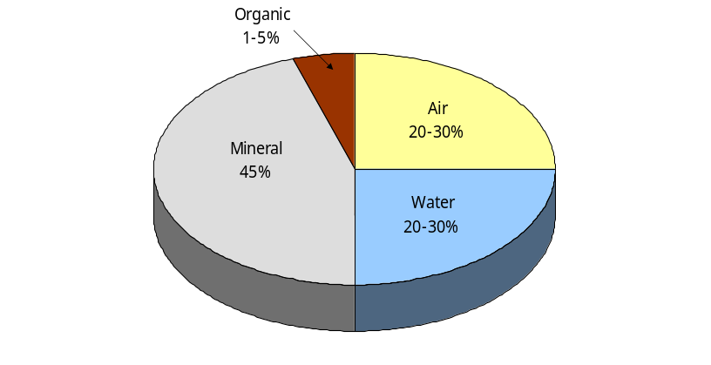

How soils are formed? – Soil forming factors
Soil forming factors
Climate
Organisms (biological factors)
Parent Material
Topography (also called relief or landscape position)
Time

*memory trick (Clorpt)

Major types of parent materials:
Minerals and rocks
Residual (weathered in place)
Transported - Colluvial
Water transported – alluvial (floodplains, alluvial terraces)
Glacial deposits (transported by ice)
Wind deposits (loess, eolian sand)
Marine (sea) and lacustrine (freshwater lakes) deposits

Soil Horizons

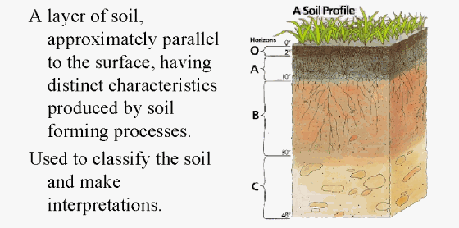

A
E
B
C
R
O
Organic layer.
----------------------------------------
Organic matter accumulation.
-----------------------------------------
Zone of eluviation – loss of clay, Fe, Al, etc.
-----------------------------------------

Zone of accumulation (clay, Fe, Al, CaC03, salts…). Forms below O, A, or E horizon.

-----------------------------------------
Little pedogenic alteration.. Commonly it is undonsilidated parent material or soft bedrock.
-----------------------------------------

Hard, continuous bedrock.

- The above horizons are common in Pennsylvania. Most soils do not contain every horizon.

- How do we differentiate horizons? (changes in color, texture, structure, roots, redoximorphic features (mottling) or other.
Soil Texture – sand, silt, clay
Sand - feels gritty
Silt - feels floury
Clay - sticky when wet
Loams – mixture of materials

- high silt soils and loams are most conducive to plant growth
- How does texture affect water in soils?
The soil textural triangle and the key to soil texture by feel are to be available for the test.

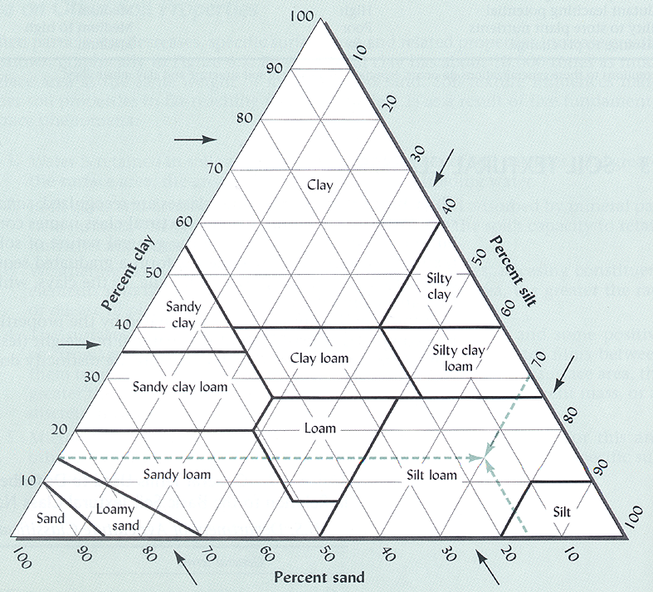

Soil Textural Triangle

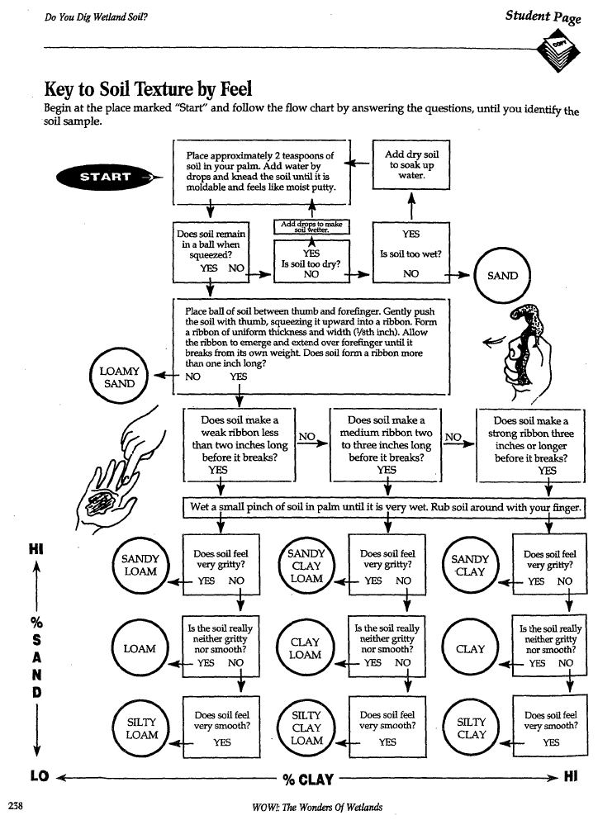

Soil Structure
The naturally occurring arrangement of soil particles. Each individual unit is called a ped. Near surface soil structure is often influenced by land use and management.

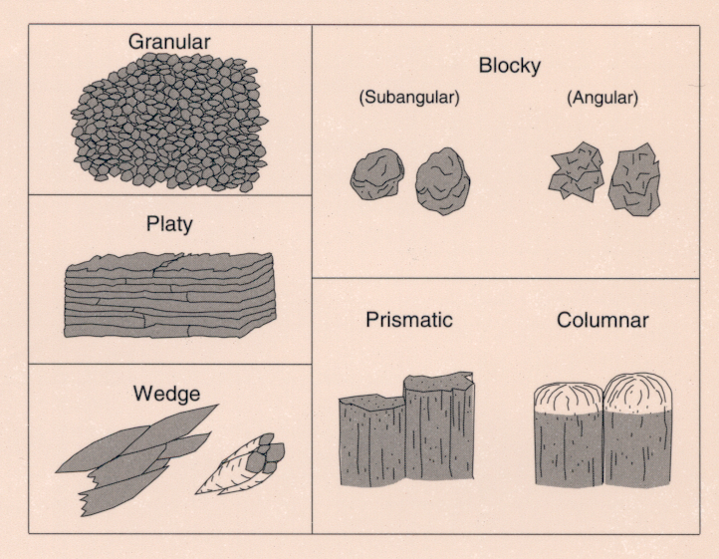

Soil Color
Determined by air and water drainage, organic matter, parent material

Topsoil – dark organic matter – vegetation, soil critters,
Subsoil – less OM
Red soils – often high iron, well-drained (example of a rusty pipe)
Wet Soil - Lack of oxygen (air) – leads to grey colors and redoximorphic
concentrations and depletions (mottling)

Soil pH
Soil pH thus affects the availability
of several plant nutrients.

A pH range of 6 to 7 is generally most favorable for plant growth
sources. This is considered neutral to slightly acidic.

Great diversity of pH difference in Pennsylvania, although soils are more likely to be acidic than alkaline.

Low pH soils can be adjusted by adding lime. High pH soils can be adjusted by adding sulfur or sulfuric acid.

Soil Survey
Designed to:
Delineate different soils across the landscape
Predict soil behavior for different uses
Highlight limitations and hazards inherent in the soil

Includes:
Text
General description
Map units descriptions
Use and Management
Interpretive tables
Maps

Over 70,000 different kinds of soil have been delineated in the United States
In a soil survey, soils are classified into map units which consist of one or more soil
series within a slope class.
A soil series (or soil type) has a combination of traits unique to it such as parent material, texture, drainage, and landscape position.

Slope gradient (or slope) is the steepness of the land. It is the rise or fall in a given distance and is usually measured in percent. Example: If a hillside is 100 feet long and drops 10 feet in elevation from the top of the slope to the bottom of the slope, then the slope is 10%.

Delineated on the maps are individual Map units. These show the different soil series (types) across the landscape. The first letter denotes the soil series and special feature, the last large letter denotes the slope phase.

Note the document entitled “How do I use a soil survey” to be available to use on the test.

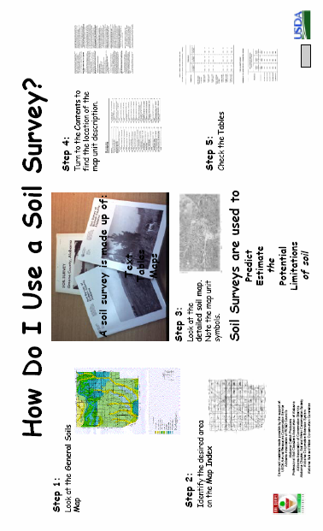

Supplies
Soil samples for question
Soil profiles
Small display board
Rusty pipe
Water and buckets for cleaning
33 copies handouts
8 copies of test
33 answer sheets

